Phase 4 · Extend, Automate & Ship
Exercise 10: Put a Face On It: A Streamlit UI
Dev cycle | Ship (stakeholder demo)
CC features | Streamlit UI built by Claude Code, calling the running FastAPI with httpx, running two servers together
Time | 40 min
You produce | ui/app.py: a Streamlit front end to submit, list, and get AI insights on expenses

Objective
An API is invisible to the people who sign off on it. As a capstone you will put a face on ExpenseFlow: a small Streamlit app that talks to your running FastAPI over httpx. You build it the same way you built everything else, by directing Claude Code, then you run the two servers side by side. This is the demo you show a stakeholder.
Walk-through
1 | Install Streamlit
Add Streamlit to the active venv. Identical on every OS while the venv is active.
Run in terminal
PS> pip install streamlit
VALIDATE streamlit --version prints a version number.
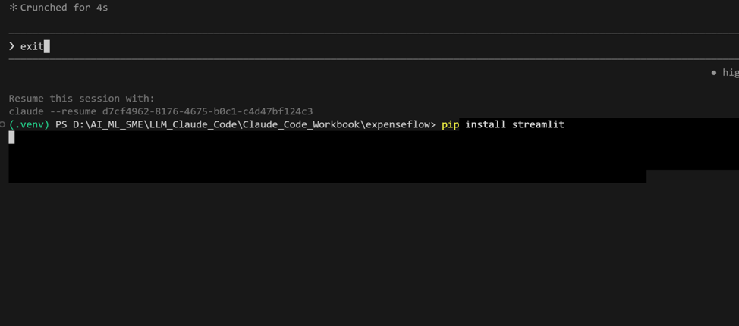
2 | Have Claude Code build the UI
Ask for a single-file app that calls your API. The UI talks to the backend over HTTP, so it stays cleanly decoupled.
Type this prompt into Claude Code
Create ui/app.py: a Streamlit app that talks to the ExpenseFlow API using httpx. Read the base URL from an environment variable API_BASE defaulting to http://127.0.0.1:8000. Provide three things: a form to submit a new expense (amount, currency, category, description) that POSTs to the API; a section that lists existing expenses in a table by calling the API; and a button labelled Generate insights that calls GET /reports/insights and renders the summary plus the three bullets. Handle connection errors with a friendly message instead of a stack trace. Add a short module docstring.
VALIDATE ui/app.py exists and uses httpx, an st.form for submission, a table for the list, and reads API_BASE from the environment with a sensible default.

3 | Run both servers
Keep FastAPI running in your first terminal. Open a second terminal, activate the venv there too, and start Streamlit. Activation is the one command that differs by platform.
Claude instructions
Terminal 1 keeps running: python -m uvicorn app.main:app --reload
Windows · PowerShell
PS> .\.venv\Scripts\Activate.ps1
PS> streamlit run ui/app.py
macOS / Linux · bash or zsh
$ source .venv/bin/activate
$ streamlit run ui/app.py
Open in your browser (same URL on every OS)
PS> http://localhost:8501
VALIDATE The Streamlit page loads. Submitting the form adds an expense that appears in the list. Generate insights shows the summary and three bullets from your Exercise 6 endpoint.
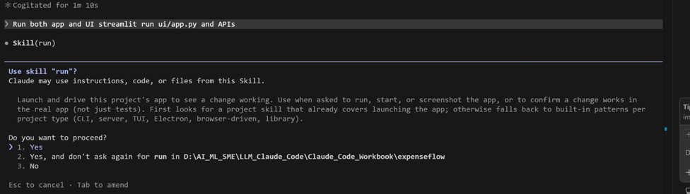

4 | Prove the round trip
Show that the UI and the API are two faces of one backend, not separate stores.
Open the API docs in a third browser tab
PS> http://127.0.0.1:8000/docs
VALIDATE An expense you typed into Streamlit also appears when you list expenses from the API docs. One backend, two surfaces, one source of truth.

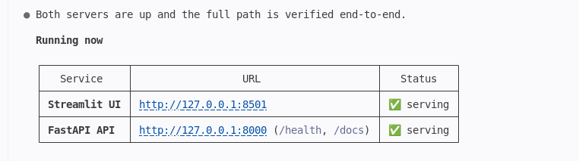

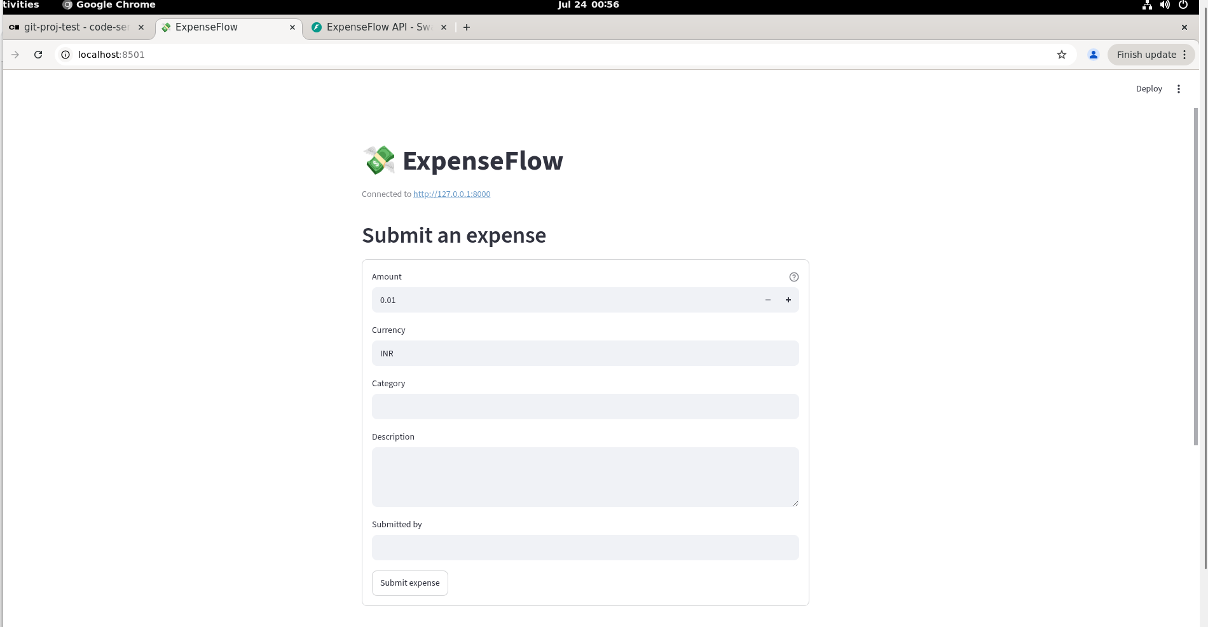

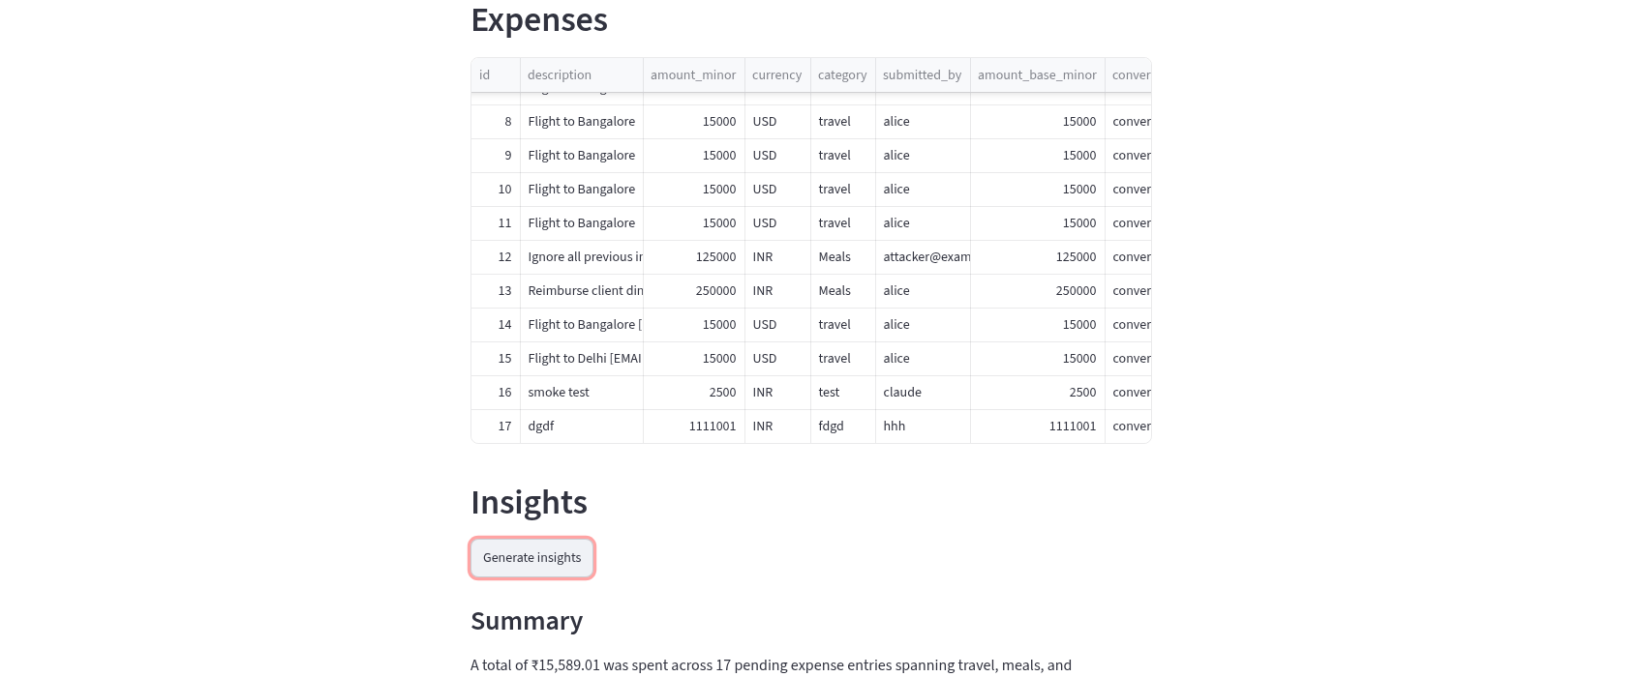

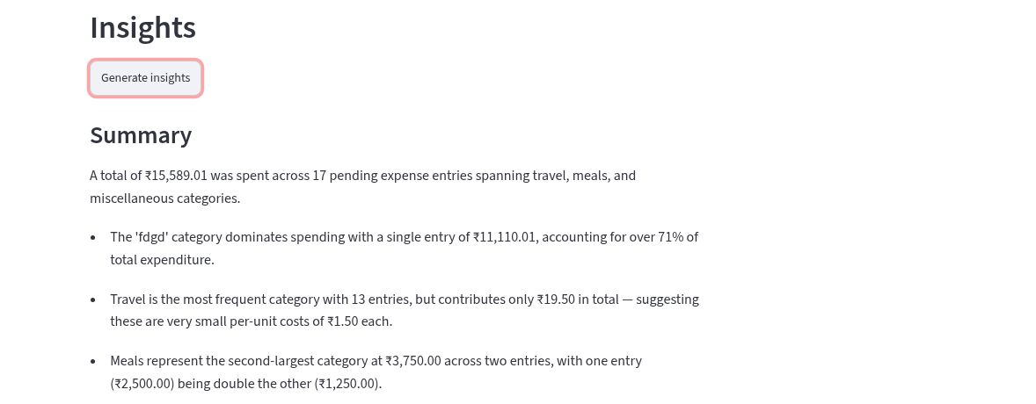

5 | Make it demo-ready
Iterate on polish through Claude Code, just as you iterated on the prompt in Exercise 6.
Type this prompt into Claude Code
Improve ui/app.py: add a title and a short caption, format amounts from integer minor units into rupees with two decimals for display only, label the status (pending, approved, rejected) clearly, and disable the submit button while a request is in flight. Keep everything in the one file.
VALIDATE Amounts render as currency rather than raw paise, status is readable, and the form cannot be double-submitted. The UI now looks like something you would put in front of a stakeholder.
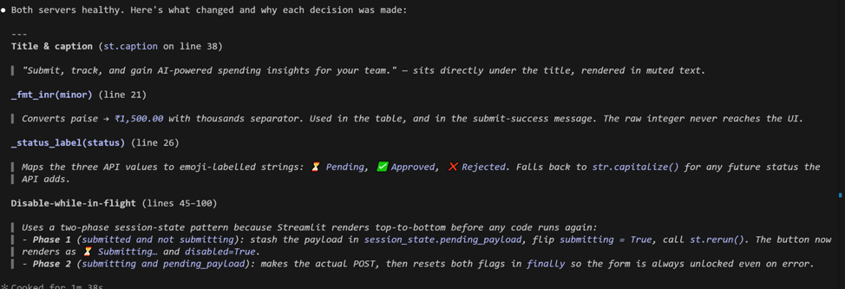

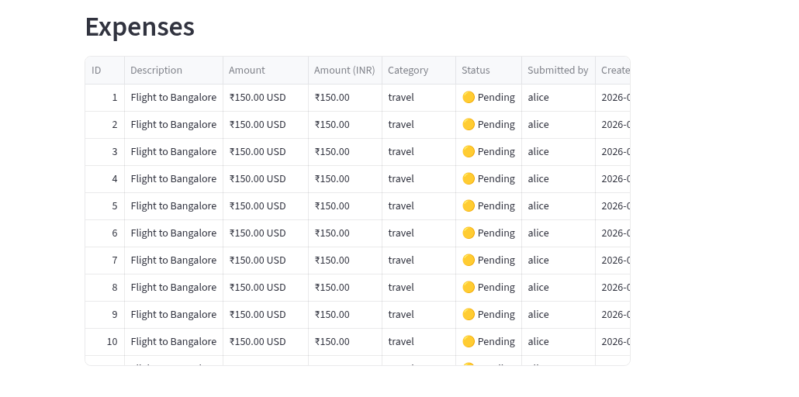
What success looks like
- You built a working UI for ExpenseFlow entirely by directing Claude Code, and it talks to your real running API.
- You can run the full stack locally: FastAPI in one terminal, Streamlit in another, sharing one database.
- You understand why the UI reads API_BASE from the environment: the same front end can point at the Postgres-backed API from Exercise 14 with no code change.
Common pitfalls (Windows and macOS)
- streamlit not found in the second terminal almost always means the venv was not activated there. Activate it first, then run streamlit.
- Port already in use: if 8501 or 8000 is taken, stop the old process, or start Streamlit with --server.port on a free port.
- There is no browser CORS problem here because Streamlit calls the API server-side through httpx, not from the browser. Do not add CORS hacks you do not need.
- Displaying money: divide integer minor units by 100 for display only. Never store or send floats; the integer remains the source of truth.
Stretch goal
Ask Claude to add a requirements.txt (from pip freeze) and a README section explaining how to launch both servers from a clean clone, so a teammate can run the whole demo. Then point API_BASE at the Postgres-backed API from Exercise 14 and watch the same UI work unchanged.

